Question 1 : Create a simple tkinter window with a title "My First tkinter App" and dimensions 400x300 pixels.
Hints: Use Tk(), title(), and geometry() methods.

Question 2 : Add a label to the window that says "Welcome to tkinter!".
Hints: Use the Label widget and the pack() method to display it.

Question 3: Add a button to the window that says "Click Me!". When clicked, it should print "Button Clicked!" in the console.
Hints: Use the Button widget and the command parameter to bind a function.

Question 4: Add an entry widget for user input and a button that, when clicked, displays the entered text in a label below the entry.
Hints: Use Entry and Label widgets, and the get() method of the Entry widget

Question 5: create a simple calculator
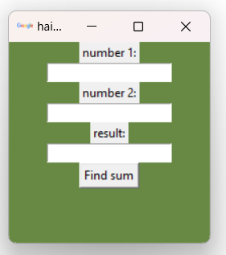
Hints :
def findSum():
sum=int(n1.get())+int(n2.get())
result.set(sum)

Question 6: Create a 3x3 grid of buttons in a tkinter window.
Hints: Use the grid() method and specify row and column parameters.

Question 7: Create a small form with the following:
A label "Name:"
An entry widget for the name
A label "Age:"
An entry widget for the age
A submit button that prints "Name: [name], Age: [age]" in the console when clicked.
Hints: Combine Label, Entry, and Button widgets, and use the get() method of Entry widgets to retrieve the input.

